Motivating the Movement: Advocating, Building and Collaborating Together

2023 Annual State Convention

National Federation of the Blind of Michigan
Robert Parsons, Jr., M. A., CRC, CVRT, LLPC| President

Friday, November 10, 2023 – Sunday, November 12, 2023

DoubleTree by Hilton Hotel Detroit - Dearborn
5801 Southfield Fwy.
Detroit, MI 48228
(313) 336-3340

Message from the President
Happy state convention and greetings to our Federation family, friends, and attendees this year as we make our long-anticipated return to Detroit! It is with great excitement that the National Federation of the Blind of Michigan is back with an in-person convention experience that offers a variety of seminars, discussions, and innovative breakout session topics for all to enjoy and further empower themselves from. The resources and connections offered at this, the largest gathering of blind people coordinated by blind people in the state of Michigan, has the potential to support you in your future endeavors. So, whether it’s academic, social, or vocational; please use the opportunities to network this weekend to your advantage.
Our convention theme this year, “Motivating the Movement,” is reflected in much of our convention programming, where some of our breakout sessions and seminars on Friday afternoon highlight some of the fundamental principles of the Federation or pivotal skills that blind people use to be successful. Our national president, Mark Riccobono, articulated a separation from the Vision Industrial Complex in his 2023 National Banquet Address. I invite you, Federationists, guests and attendees; to vacate the Vision Industrial Complex and venture into the mission of the Federation: to secure equality, opportunity, and security for the blind. Engaging in our breakout and general sessions, making your voice heard as a dues-paying member of our proud organization and advocating with us as we continue to affect change for Michigan’s blind in different facets of our lives. The National Federation of the Blind of Michigan is one of 52 affiliates that supports our national office. We are both humbled and elated to have our President Emeritus, Dr. Marc Maurer, serving as our national representative. His experience, coupled with the opportunities for both learning and leadership throughout the weekend, motivates me for what our next year can look like together. I look forward to hearing all of your feedback and ideas for the future as we live the lives we want!

With Love, Hope and Determination

Robert Parsons, Jr., President

NFB Pledge
I pledge to participate actively in the efforts of the National Federation of the Blind to achieve equality, opportunity, and security for the blind; to support the policies and programs of the Federation; and to abide by its constitution.

NFB One-Minute Message
The National Federation of the Blind knows that blindness is not the characteristic that defines you or your future. Every day we raise the expectations of blind people, because low expectations create obstacles between blind people and our dreams. You can live the life you want; blindness is not what holds you back.

A message from our Sponsors

Bureau of Services for Blind Persons – Gold Sponsor

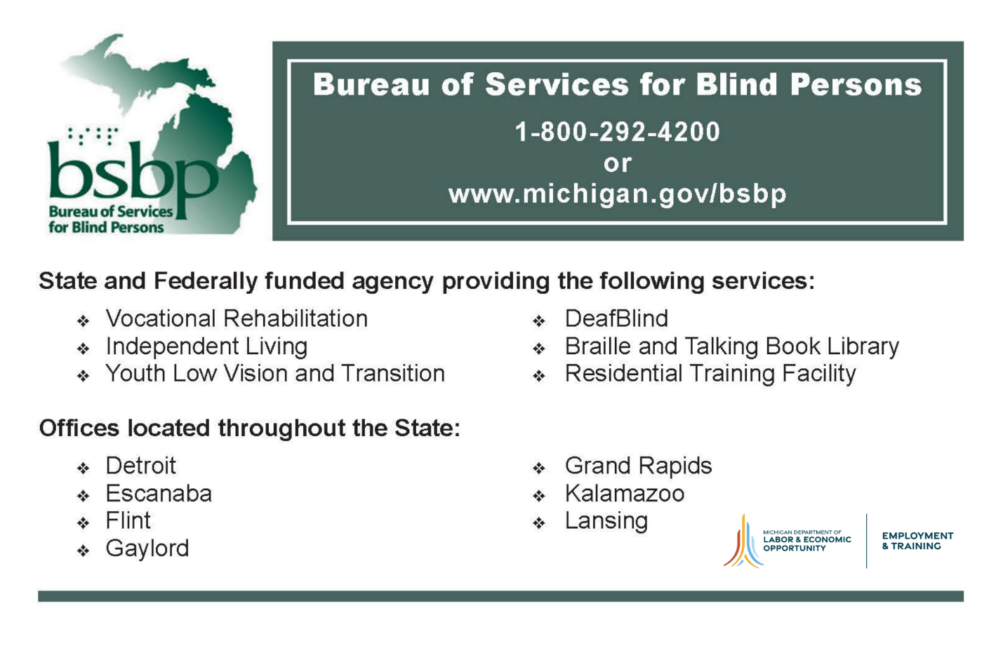

Michigan Department of Education: Low Incidence Outreach – Gold Sponsor
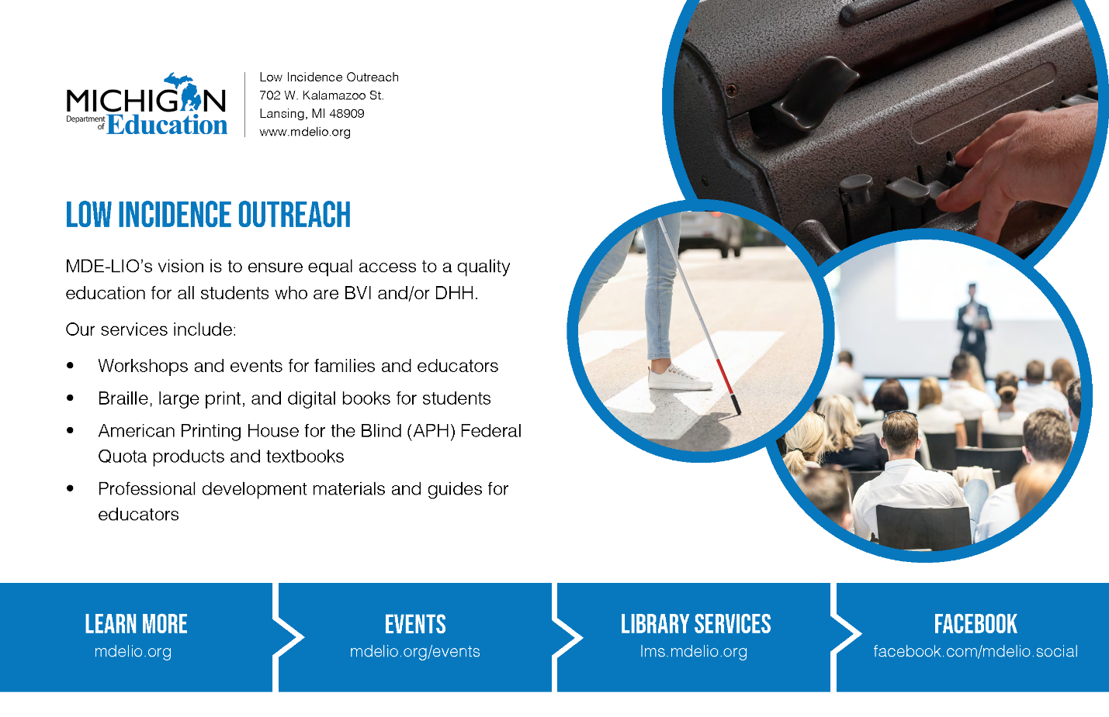

Leader Dogs for the Blind – White Cane Sponsor
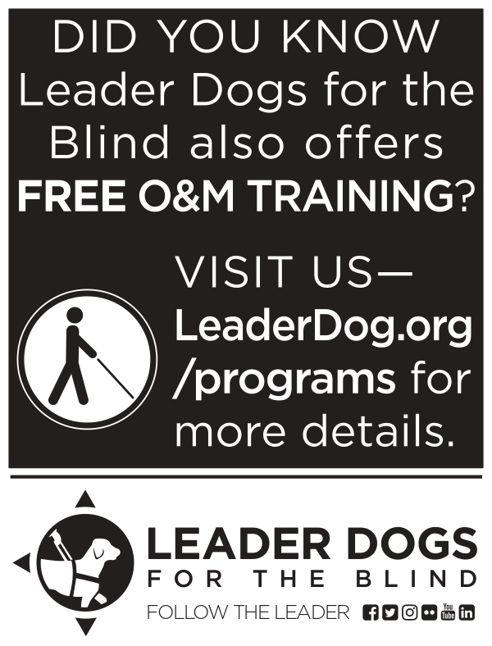

NON-24/VANDA PHARMACEUTICALS

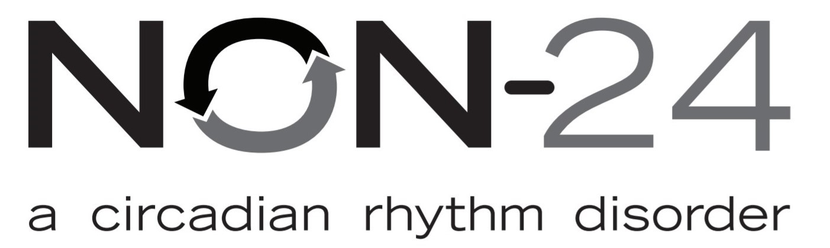
Non-24 is a chronic disorder that disrupts a person’s circadian rhythm causing the internal body clock to become out of sync with the 24-hour day-night cycle. This can lead to sleep struggles with periods of good sleep followed by periods of poor sleep. Vanda Pharmaceuticals, Inc. is a global biopharmaceutical company focused on development of innovative therapies for unmet medical needs and continues research on circadian rhythm disorders and Non-24.

For more information, call 202-875-4714, visitNon-24.com, or Email Jennifer.lyman@vandapharma.com.

NFBMI Debaters’ Dunk
The National Federation of the Blind of Michigan believes in the power of independent and collective advocacy to turn our dreams into reality. Our local chapters and state division leaders use these skills to grow our membership and help build the Federation. At various sessions and meetings throughout the weekend, a leader from participating chapters and divisions will be promoting the brand and work of the Federation in our fundraising campaign to support our members attendance at our 2024 Washington Seminar. Please take time to learn about the wonderful work our affiliate is doing and consider pledging your support to a leader in this fundraiser. Each pledge supports the leader and their chapter’s campaign in this activity, with chapters competing for a number of prizes and a chance to avoid our inaugural dunk. Campaign pledges will be accepted until the convention banquet, where each leader will be able to provide their final rebuttal for your support in the pledge competition with their fellow Federationists.

Hotel Shuttle
A free shuttle is available from Detroit Metro Airport as well as the Dearborn Amtrak station. Please call the hotel at (313) 336-3340 upon arrival to request a shuttle.

Tell Your Friends
We encourage you to talk about the convention with your friends on social media. Our official hash tag is #NFBMI23.

Convention Registration
We encourage everyone to register for the convention. Everyone who registers for the convention will be eligible to win door prizes that will be given away throughout the weekend. Additionally, current members of a local chapter or state division in Michigan will be eligible to vote during resolutions and elections.

Limited banquet tickets will be available for purchase at the convention. In-person registration is $20 and banquet tickets are $45. Registration is open in the ballroom foyer on Friday evening from 4:00 pm to 7:00 pm and Saturday morning from 8:00 am to 8:45 am at our affiliate information table.

Child Care Services
Rotunda

The National Federation of the Blind of Michigan is a strong proponent of effective blind parenting and child rearing. We are excited to provide childcare services for parents that hope to maximize their convention experience. Please feel free to visit the Rotunda area during general session and the banquet on Saturday to ensure you can access this service and more opportunities for active decision-making and updates. Child care services will also be offered during the annual business meeting on Sunday morning.

Inclusivity, Diversity, and Code of Conduct
We are committed to providing a welcoming, safe, and healthy environment for everyone. Thank you for cultivating an atmosphere of mutual respect where participants from diverse backgrounds can learn, network, and share with each other. We are committed to diversity, equity, and the free expression of ideas. These principles have been outlined in our Code of Conduct found at https://nfb.org/codeofconduct.

We recognize a shared responsibility to create and uphold an inclusive atmosphere for the benefit of all. Prohibited behaviors include harassment, sexual misconduct, and inappropriate use of the NFB virtual convention platform. Prohibited behavior or misuse of the platform will not be tolerated and may result in removal from the convention and other consequences.

For assistance or to report an incident at the convention, please call
(410) 659-9314, extension 2475, or email code@nfb.org. All reports will be fully investigated according to the steps outlined in our code of conduct. Thank you for doing your part to contribute to our community and the high expectations we strive to maintain at all our events.

Door Prizes
Door prizes will be drawn periodically throughout the convention during Michigan’s Got Talent, general session and our banquet. Anyone is eligible to win a door prize if they are registered for the convention and are present in the room when their name is called. If you are hoping to donate a door prize at convention, please locate Rachel Newland, affiliate secretary, or email secretary@nfbmi.org.

Friday, November 10, 2023

1:00 pm – 6:00 pm Exhibit Hall–Great Room
Stop by our exhibit hall, where a variety of chapters, divisions, exhibitors and vendors will be eager to share their latest products and services with you. While networking with vendors; learn about options for access technology, services that may benefit you, and purchase some great products. Please check our website or the Great Hall for a list of exhibitors.

1:00 pm – 4:00 pm Braille Carnival– Erie/Ontario Rooms
Event Generously Sponsored by the NFBMI Detroit Chapter.

The National Federation of the Blind of Michigan promotes braille literacy and enrichment because it is connected to academic and vocational success. Join our membership as we highlight the different ways braille can be effectively used in activities of daily life. Our braille instruction, leisure, literacy and technology stations provide information for braille learners or users of all ages. Work on your reading speed, learn about community and state resources, or establish connections with other braille users that have the potential to create future opportunities for everyone.

1:00 pm – 2:00 pm Blindness Skills Training 101 – Huron Room
Rachel Newland, Secretary, National Federation of the Blind of Michigan
Victor Marques, At Large Chapter Secretary, National federation of the Blind of Michigan

The National Federation of the Blind believes in the potential of blind people. Often our expectations can be lowered due to misconceptions of blindness. Receiving skills training has proven to be a positive effect on the confidence, independence and exploration of the blind. Join NFB leaders in this informational seminar that outlines different areas of training that can benefit blind people. While there, take advantage of the information about state and national resources for training.

1:00 pm – 2:00 pm Membership Building and Leadership Development – Greenfield Room
Michael Powell, Board Member, National federation of the Blind of Michigan
Darryl Rice, Board Member, National Federation of the Blind of Michigan

Are you new to the National Federation of the Blind or a long-time member interested in learning how to build a stronger chapter or division? Hear various members explain the fundamentals of Federation membership and the important role of participating at the local, state, and national levels of the organization. This is an interactive session, so please bring your questions to learn about the diverse roles within the Federation.

2:00 pm – 3:00 pm Federation Philosophy: The X Factor– Huron Room
Marc Maurer, President Emeritus, National Federation of the Blind
Richard Clay, Board Member and Detroit Chapter President, National Federation of the Blind of Michigan

The approach of members of the National Federation of the Blind differ from that of other organizations. Our unique philosophical stance has proven successful in achieving our goals and ensuring equality for blind people nationwide. Take some time to join this seminar and learn how our philosophy works in tandem with our programs and how you can use it in real-world situations.

2:00 pm – 3:00 pm Presentation is Key: Tips for Success– Greenfield Room
Mark Eagle, Treasurer, National federation of the Blind of Michigan
Felecia Bradford, Flint-Genessee Chapter Secretary, National Federation of the Blind of Michigan

Whether you are preparing for a job interview or attending your first day of classes, the way a person presents themselves in public can influence the way they are considered by others. Join leaders of the NFB as we highlight tips on how blind people can effectively represent themselves in public using different skills and resources. This interactive seminar also offers opportunities for attendees to ask questions and receive feedback.

3:00 pm – 4:00 pm Advocacy in Action Seminar– Huron Room
Sheila Fulmore, Flint-Genessee Chapter President, National federation of the Blind of Michigan
Sabrina Rice, Second Vice President, National Federation of the Blind of Michigan

The National Federation of the Blind believes advocacy is an important tool for creating opportunities for growth and independence. Learn how various individuals use advocacy in different areas of life to accomplish goals and turn dreams into reality.

3:00 pm – 4:00 pm Job Exploration Lounge– Greenfield Room
Robert Parsons, Jr., President, National Federation of the Blind of Michigan
Jason Meddaugh, First Vice President, National Federation of the Blind of Michigan
Sanho Steele-louchart, Esq., Legal Program Coordinator, National Federation of the Blind
Fred Wurtzel, Capital Region President, National Federation of the Blind of Michigan

Capitalize on employment opportunities at convention by better understanding your vocational strengths and areas of growth. At our employment search lounge attendees will have an opportunity to participate in mock interviews, perfect their elevator pitch, receive benefits counseling information and even learn how to complete a career interest assessment. The road to opportunity can begin with the skills developed here.

4:00 pm – 6:00 pm Resolutions Committee Meeting – Huron Room
Steve Handschu, Resolutions Committee Chair, National federation of the Blind of Michigan

Do you believe the National Federation of the blind should take a specific position on an issue? Please bring your ideas and resolutions to this meeting. This is where the policies of the organization take place. Everyone is welcome to attend. Please try to submit resolutions in writing prior to the state convention to Chairperson Steve Handschu at stephenhandshu@gmail.com.

4:00 - 7:00 PM Registration – Superior/Michigan Room Foyer
We encourage everyone to register for the convention. Limited banquet tickets will be available for purchase at our NFB of Michigan exhibit hall table. Registration is $20 and banquet tickets are $45.

8:00 pm – 11:00 pm Michigan’s Got

Talent– Superior/Michigan Rooms
General Admission $15

Join the Michigan Association of Blind Students as they host the second “Michigan’s Got Talent,” showcase and hospitality event. Support blind students as they encourage blind people across our great state during their performances in an encouraging atmosphere that shows our Federation family at its finest. Our annual hospitality event offers attendees great entertainment, refreshments, door prizes and a cash bar while they celebrate with the Federation. Our theme is “Back in Black,” so wear something black to celebrate the return of our student division. The doors for this event will open at 7:30pm and attendees must show their admission wristband upon arrival.

Saturday, November 11, 2023

8:00 am – 8:45 am Registration – Superior/Michigan Room Foyer
We encourage everyone to register for the convention. Limited banquet tickets will be available for purchase in-person. Registration is $20 and banquet tickets are $45.

9:00 am – 12:00 pm Opening General Session – Superior/Michigan Rooms
9:00 am Call to Order and Welcoming Remarks, Robert Parsons, Jr., President, National Federation of the blind of Michigan
9:10am A Welcome from our Host, Richard Clay, Detroit Chapter President, National Federation of the Blind of Michigan
9:20 am A Message from Our National Office, Dr. Marc Maurer, President Emeritus, National Federation of the Blind
9:40 am NABS Report, Gene Kim, Secretary, National Association of Blind Students
9:50 am, Introducing the NFBMI Debaters’ Dunk Campaign, Mark Eagle, Treasurer, National Federation of the Blind of Michigan
10:00am Introducing the 2023 Scholarship Finalist, Sabrina Rice, Scholarship Committee Chair, National Federation of the Blind of Michigan
10:15 am Continuing Effective Education for Blind and Low Vision Youth, Roxanne Balfour, Director, Michigan Department of Education Low Incidents Outreach
10:30am Innovations in state services for Blind and Low Vision Consumers, William Robinson, Director, Bureau of Services for Blind Persons (BSBP)
10:45 am Updates on the Business Enterprise Program, Ben Ploch, Chair of Elected Operators Committee, Business Enterprise Program
11:00am A Journey in Employment Advocacy, Jerusalem Crawley, President, Michigan Association of Blind Students
11:15am Careers in the field of rehabilitation at Western Michigan University, Elyse Coners, PhD. CVRT, COMS, Associate Professor Department of Blindness and low Vision studies
11:30am Empowerment from Convention: How the NFB Connects Us to Opportunity, Tara Morgan, Board Member, National Federation of the blind of Michigan
11:45am Blind Entrepreneurs Panel, Jason Meddaugh, , Owner, A. T. Guys; Sabrina Rice, CEO Eye Learn; Darryl Rice, CEO, EVAY One Services
12:00 pm Adjourn for Lunch

12:00 PM Pizza Lunch Buffet – Dearborn/Allen Park/Southfield rooms
$25 per person. Must be purchased in advance at registration.

12:00 pm – 4:00 pm Exhibit Hall – Great Room

1:30 pm –5:00 pm Afternoon Breakout Sessions

1:30 pm – 2:30 pm Blind Seniors Advocating for Seniors (BSAS) Annual Seminar – Superior/Michigan Rooms
Patricia Pyle, President, Blind Seniors Advocating for Seniors
Lisa Kisiel, Director of Field Services, Bureau of Services for Blind Persons
Gwen McNeal, East Regional Director, Bureau of Services for Blind Persons

Are you losing your vision as you settle into retirement and wondering how to deal with your vision loss as you enter into your golden years of life? Have you been blind your whole life and are looking to meet other blind people who share some of the same goals and interests as you? Please join the senior division as they hold their annual meeting to pay annual dues, meet other members, and discuss general goals and directions of the division. There will also be a special presentation from the Bureau of Services for Blind Persons on services that are available for seniors and how you can determine your eligibility for these services.

1:30 pm – 2:30 pm Michigan Association of Blind Students (MIABS) Annual Business Meeting – Greenfield Room
Jerusalem Crawley, President, Michigan Association of Blind Students
Gene Kim, Secretary, National Association of Blind Students

Are you a blind high school or college student looking to network with others on aspects of student life? Join the Michigan Association of Blind Students for their first in-person business meeting since the pandemic where they will discuss important programs, accept new members through collecting dues and hold elections to determine leaders of our organization.

1:30 pm – 2:30 pm Access Technology Resource Fair – Eerie/Ontario Rooms
Ather Jammoa, Lead Technology Instructor, Eye Learn
Danielle Montour, Independent Access Technology Consultant, National Federation of the Blind of New York
Patricia Love, Independent Contractor, Michigan Department of Education| Low Incidence Outreach

Is access technology your passion? Our technology resource fair offers attendees opportunities to learn about cutting edge devices, applications, software and programs that can help blind people become more efficient in different aspects of life.

1:30 pm – 2:30 pm Health and Wellness Seminar – Huron Room
Marilyn Green, President, National Federation of the Blind of Illinois
Robert Parsons, Jr., President, National Federation of the Blind of Michigan

Achieving and maintaining wellness can be difficult in the post-pandemic era. This session provides attendees with opportunities to learn about physical and mental health activities, interventions, resources and services that blind people have incorporated into their daily lives.

2:45 pm – 3:45 pm Public Transit Advocacy Seminar – Greenfield Room
Jason Meddaugh, First Vice President, National Federation of the Blind of Michigan
Fred Wurtzel, Capital Region Chapter President, National Federation of the Blind of Michigan

Access to quality public and paratransit services are often an advocacy initiative of the National Federation of the Blind. Join our leaders and members as we discuss strides taken locally and statewide to advocate for quality transportation services. Learn how you can get involved in these efforts to create the change you need to live the life you want.

2:45 pm – 3:45 pm NFBMI At Large Chapter Meeting – Superior/Michigan Rooms
Rachel Newland, At Large Chapter Vice President, National Federation of the Blind of Michigan
Victor Marques, At Large Chapter Secretary, National Federation of the Blind of Michigan

The At Large chapter of the NFB of Michigan is a statewide chapter that meets monthly via Zoom to support members that are not physically located near a local chapter or are unable to make in-person meetings. Join us as we meet for our first in-person meeting, where we will discuss the direction of our chapter efforts and how we can continue to build the Federation. Opportunities for chapter membership, annual dues and elections will be available.

2:45 pm – 3:45 pm Braille Around the House– Erie/Ontario Rooms
Tara Morgan, Board Member, National Federation of the Blind of Michigan
Danielle Montour, Independent Technology Consultant, National Federation of the Blind of New York
Generously Sponsored by the NFBMI Detroit Chapter

Braille and tactile techniques are among some of the most effective tools that blind people use in their daily lives. Though some people consider braille to be academic or for employment, the National Federation of the Blind believes otherwise. Join us as we showcase the usefulness of braille, bump dots and other tactile home tools that can make activities of daily life easy, fun and manageable.

3:00 pm – 5:00 pm Self-Defense Seminar– Huron Room
Steve Handschu, Self-Defense Instructor, Detroit Chapter, National Federation of the Blind of Michigan

Can blind people defend themselves effectively? Yes we can. This seminar will introduce affective self-defense training techniques for blind people by blind people. Learn how to defuse, avoid, and protect yourself in difficult situations.

6:00 pm Happy Hour Social Hour – Ballroom Foyer

7:00 pm –10:00 pm Banquet General Session – Superior/Michigan Rooms

INVOCATION- Leo Naypier, Vice President, Flint Genessee Chapter, National Federation of the Blind of Michigan.
INTRODUCTIONS AND PRESENTATIONS
The Michigan PAC Report
NFBMI Debaters’ Dunk Campaign Update and Rebuttals
Keynote Address, Dr. Marc Maurer, President Emeritus, National Federation of the Blind
Scholarship Awards Presentation, Sabrina Rice, Scholarship Committee Chair, National Federation of the Blind of Michigan
Investing in Our Future with NFBMI REAL – Sheila Fulmore, Flint Genessee Chapter President, National Federation of the Blind of Michigan, Ather Jammoa, Communications Chair, National Federation of the Blind of Michigan
NFBMI White Cane Winners Update, Mark Eagle, Fundraising Chair, National Federation of the Blind of Michigan

10:00 pm Banquet Adjourn
Join us on the patio poolside after the banquet for the culmination of our fund raiser and for your chance to try your hand at the dunk tank!

Sunday, November 6, 2022

9:00 am – 12:00 pm Business General Session – Superior/Michigan Rooms

President’s Report – Robert Parsons, Jr.
Secretary’s report – Rachel Newland
Treasurer’s Report - Mark Eagle
Convention Voting Logistics
Election of Board Members
Delegate and Alternate Delegate for 2024 National Convention
Resolutions Committee Report – Steve Handschu
2024Washington Seminar Planning
2024National Convention Planning
2024 NFB of Michigan Convention
State Division Reports: Seniors, Students
Chapter Reports: At Large, Capital Region, Flint-Genessee, Jackson, New Wayne County, Detroit
Old and new business
Adjourn

Thank You!

Thank you for participating in the National Federation of the Blind of Michigan 2023 state convention. We hope to see you again next year at the 2024 state convention, or at your next local chapter or division meeting.

