“Structuring our Discoveries”

2025 Annual State Convention

National Federation of the Blind of Michigan
Robert Parsons, Jr., MA, CRC, CVE, CVRT, LPC| President

Thursday, October 30, 2025 – Sunday, November 2, 2025

Auburn Hills Marriott Pontiac
3600 Centerpoint Pkwy
Pontiac, MI 48341

Message from the President
Greetings and welcome to the 2025 state convention of the National Federation of the Blind of Michigan; where blindness is not the characteristic that defines you or your future. Our convention theme this year, “Structuring our discoveries,” is a return to our philosophical roots, where we both acknowledge and actively embrace our practice as proud Federationists informed by the rich history of the structured discovery methodology. This celebratory weekend can be defined as an opportunity reservoir, for Michiganders will be provided access to opportunities that otherwise may have been blocked in past years, with their voices being elevated in places otherwise thought unreachable. I welcome the unprecedented number of pre-registered attendees this year, surpassing previous expectations despite social climate uncertainties. Furthermore, the Michigan affiliate humbly welcomes our esteemed guest, President Mark Riccobono, to share his wisdom, along with various other experiences with the Michigan blind people’s movement. During this weekend, I encourage our attendees, guests, and members to engage with all that our convention has to offer; specifically leaning into the educational facets of Federation philosophical programming about structured discovery and its history. In a world where the rights of the blind are being redefined by parties that do not represent them, this convention, the leading authority of this organization; is made up of sessions completely coordinated by Michigan’s blind. With love, hope and determination; we can turn dreams into reality. . Let’s continue to build the Federation, together.

Respectfully,

Robert Parsons, Jr., MA, CRC, CVE, CVRT, LPC, President

NFB Pledge
I pledge to participate actively in the efforts of the National Federation of the Blind to achieve equality, opportunity, and security for the blind; to support the policies and programs of the Federation; and to abide by its constitution.

NFB Belief Statement
The National Federation of the Blind advances the lives of its members and all blind people in the United States. We know that blindness is not the characteristic that defines you or your future. Every day, we raise the expectations of blind people because low expectations create obstacles between blind people and our dreams. Our collective power, determination, and diversity achieve the aspirations of all blind people.

Tell Your Friends
We encourage all attendees to talk about the convention with your friends on social media. Our official hash tag is #NFBMI25.

Convention Registration
We encourage everyone to register for the convention. Only registered attendees are eligible to win door prizes that are given away throughout the weekend. Additionally, registered, dues-paid members of a local chapter or state division in our affiliate are considered a part of the blind people’s movement in both Michigan and our national organization.
Limited banquet tickets will be available for purchase at the convention. In-person registration is $20, and banquet tickets are $60. Registration is located in the coat check area, found on the first Level of the hotel. The registration table will be open throughout the day on Friday and Saturday.

Assistive Listening Devices
If you are going to need an assistive listening device for our Saturday general session, Saturday banquet or the Sunday morning business meeting, please visit the front desk of the hotel.

Inclusivity, Diversity, and Code of Conduct
We are committed to providing a welcoming, safe, and healthy environment for everyone. Thank you for cultivating an atmosphere of mutual respect where participants from diverse backgrounds can learn, network, and share with each other. We are committed to diversity, equity, and the free expression of ideas. These principles have been outlined in our Code of Conduct found at https://nfb.org/codeofconduct.

We recognize a shared responsibility to create and uphold an inclusive atmosphere for the benefit of all. Prohibited behaviors include harassment, sexual misconduct, and inappropriate use of the NFB virtual convention platform. Prohibited behavior or misuse of the platform will not be tolerated and may result in removal from the convention and other consequences.

For assistance or to report an incident at the convention, please call
(410) 659-9314, extension 2475, or email code@nfb.org. All reports will be fully investigated according to the steps outlined in our code of conduct. Thank you for doing your part to contribute to our community and the high expectations we strive to maintain at all our events.

Door Prizes
Door prizes will be drawn periodically throughout the convention weekend; specifically, during the annual business meeting, Friday night hospitality event, general session, and our banquet. All registered attendees are eligible to win a door prize if they are present in the room when their name is called. If you are hoping to donate a door prize at convention, please locate Donna Posont, New Wayne County President, or inform the volunteers at the convention registration table.

NFBMI Movement Raffle
One of our fundraisers for this year’s state convention is our Michigan movement raffle. This raffle will have two drawings. One lucky winner will win $500 in cash. A great amount of money just before our traditional banquet auction. Another winner will win a trip to the 2026 NFBMI state convention. Tickets are $20 a piece, or 3 for $50. If you wish to purchase tickets seek out President Robert Parsons, Kashonia Graham, or Ather Jammoa.

A message from our sponsors

Democracy Live — Platinum Sponsor
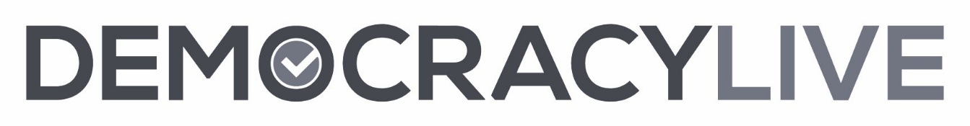
In too many states, voters with disabilities don’t have equal access to voting independently and privately from home. Fortunately, there are new accessible at-home voting technologies now available.
The Democracy Live OmniBallot accessible at-home voting system is a fully ADA Section 508, WCAG 2.2AA compliant remote ballot marking solution. The system has been tested to meet the accessibility requirements of over 90 combinations of browsers, operating systems, screen readers and devices. OmniBallot has been deployed as an accessible absentee tool since 2008, in over 5,000 elections, serving more than 2,500 jurisdictions, in 34 states and 96 countries around the world. OmniBallot has been tested and reviewed by members of most every leading disability organization in the nation.
For further information, please contact Democracy Live:
855-655-VOTE (8683) Toll Free | Email: info@democracylive.com | www.democracylive.com

Rehabilitation WAY, LLC — Platinum Sponsor
503 S. Westnedge Avenue, 1
Kalamazoo, Mi 49007
Rehabilitation WAY, LLC is a private rehabilitation practice that incorporates career empowerment and readiness into its work with people. The acronym that makes up its principles; working, accessing, and yielding; addresses the challenges to employment that all people have the potential to face. Nationally certified in various counseling specializations with an emphasis on blindness and low vision, the practice prides itself on its readiness to get you to go the distance for your goals. Whether new to blindness or still on the journey to your objective, our services can streamline your path, including:
- Access Technology Assessment
- Access Technology Training
- Disability Acceptance Counseling
- Educational Seminars/ In-Service Workshops
- Employment Readiness Groups
- Job Development, Placement and Carving Services
- Individual Career Counseling
- Workplace Accessibility Consultation
- Vocational Assessments

The path to gainful employment is attainable with access to resources and a working relationship with professionals that are like-minded with your employment goal as a priority. That is the Rehabilitation WAY! I am excited to serve as a consultant, instructor or liaison on your path to employment. As a professional, I am registered as a vendor with the Bureau of Services for Blind Persons (BSBP), Michigan Rehabilitation Services (MRS), as well as a provider that accepts most insurances.
Contact: Robert Parsons, Jr., M A, CRC, CVE, CVRT, LPC
(616) 528-4309
rehabilitationway@gmail.com

Ross Insurance Group — Platinum Sponsor

**Retire Care™**
Not knowing your retirement options can be stressful. I can help you find and focus on the optimal strategies for a financially secure future.

- Safe Retirement Planning
- Secured Growth Opportunities
- Social Security Maximization
- Medicare Maximization
- 401k Protection
**Rodney Ross, RSSA, CSA**
Financial Security Navigator™
(586) 393-3703
Rodney@RossInsurance-Advocates.com

Michigan Department of Education Resource for Blind and Low Vision (RBLV) & Resource for Deaf and Hard of Hearing (RDHH) — Gold Sponsor
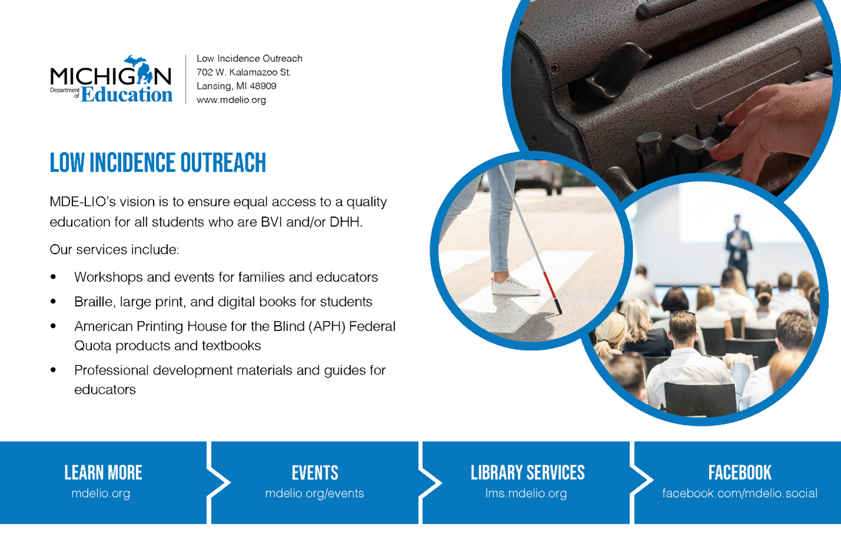
Resources for Blind and Low Vision
702 W. Kalamazoo St.
Lansing, MI 48909
www.mdelio.org
MDE-RBLV’s vision is to ensure equal access to a quality education for all students who are BVI and/or DHH.

Our services include:
• Workshops and events for families and educators
• Braille, large print, and digital books for students
• American Printing House for the Blind (APH) Federal Quota products and textbooks
• Professional development materials and guides for educators
Learn More: mdelio.org
Events: mdelio.org/events
Library Services: lms.mdelio.org
Facebook: facebook.com/mdelio.social

Family Counseling and Mediation Services — Gold Sponsor
Family Counseling and Mediation Services is a private practice in Kalamazoo since 2013.
We have four practitioners providing counseling for children, adolescents, adults, couples, and families.
Specialties include addiction, trauma, LGBTQIA2S+, children/adolescent family issues, and disability and minority issues.
In-person and virtual sessions as well as evening hours are available.
Phone number: 269-932-4973
Website: counseling-kalamazoo.com
Email: laurierudolph@counseling-kalamazoo.com

Birding by Ear and Beyond — White Cane sponsor
Birding by Ear and Beyond, a program at the Environmental Interpretive Center at the University of Michigan-Dearborn, was developed as a way for people who are blind to learn about the natural world. Participants who are blind as well as sighted families and friends are encouraged to engage all their senses in the learning processes. Those who are blind have learned to identify birds by sound, trees by touch, flowers by smell, and herbs in the butterfly garden by taste. Anyone involved in the program finds out that an understanding of nature can occur even when one is blind by using techniques that do not depend on sight. As participants explore the wonder of nature, they gain confidence in their abilities to learn about and care for the environment.
Phone number: (313) 220-8140
Email: donnabutterfly50@gmail.com

Wednesday, October 29, 2025

8 PM—Sponsor and exhibiter showcase
Stop by our affiliate Zoom room for our virtual sponsor and exhibitor showcase. Here, sponsors and exhibitors will share what they will be offering at the convention so you can be prepared for the exhibit
hall on Friday afternoon. Plus, you will be able to hear from some exhibitors who may only be at the virtual event.

Thursday, October 30, 2025

6:00 pm—NFBMI “Restaurant Outing ” Dinner Activity
Join three leaders of the National Federation of the Blind of Michigan as we embark with convention attendees on a special culinary visit to one of three local restaurants for a dinner experience. This networking opportunity aims to connect members and visitors of our convention from different areas.

Group One: Hotel Restaurant
Leader: Sheila Fulmore, (810)241 -6124

Group Two: Como’s Restaurant
Leader: Robert Parsons, (269) 216- 8640

Group Three: Rainforest Cafe
Leader: Damontae Scott, (810) 295-6422

Friday, October 31, 2025

11:00AM - 6:00 PM Registration –Coat Check area
We encourage everyone to register for the convention. Limited banquet tickets will be available for purchase at our NFB of Michigan registration table. Registration is $20 and banquet tickets are $60.

12:00 PM – 5:00 PM Exhibit Hall– Salon C/ Foyer
Stop by the NFBMI exhibit hall, where a variety of chapters, divisions, exhibitors, sponsors, and vendors are eager to share information about their latest products and services with you. While networking with our exhibitors ;learn about options for access technology and services that may benefit you.

12:00 pm – 2:00 pm MI-ABS Audio Descriptive Movie Activity — MI 5

1:00 pm – 2:30 pm Oakland County Accessible Voting Demonstration — Baldwin Perry
This session provides convention attendees with voting accessibility literature, live information and a live experience with the VAT (Voting Assistance Terminal), , accessible voting machines throughout Oakland county in election for people who are blind.

1:00 pm – 2:00 pm Scam-Proof: Protecting Your Finances in a Digital and Accessible World—Hospitality Suite — Gail Bowman, Flint/Genesee Chapter Treasurer
This presentation helps blind and blind individuals recognize, avoid, and respond to financial; scams. It includes real examples, interactive discussions, and practical safety tips.

2:05 pm – 3:00 pm Washtenaw County Meeting — Wisner Featherstone
This session provides a space for people who live in the Washtenaw county area (Ann Arbor, Saline, Chelsea, Ypsilanti, Milan, Dexter, etc.) to connect. Discussions about continued virtual meetings, as well as potential in-person programs for blind seniors and students will be provided.

3:00 pm – 5:00 pm Blind Gamer's Corner — MI 5 —NFBMI Gamer’s Guild
Have you been wishing that you could play console games, but you don't know where to get started? Have you heard your friends playing video games, and thought you couldn't join them, because of your vision? In the NFB, blindness doesn't hold us back. Thankfully, some gaming studios have realized this, and have taken countless hours to make a few of their video games completely accessible to blind and low vision individuals! Maybe you don't have a gaming console, but you still wish to play games. We will also discuss some blindness specific games, that are available to play on the PC, as well as some games that are playable on your mobile devices! Come to our gaming event, and find out about some of the awesome mainstream, as well as blindness specific games that are playable by totally blind individuals!

3:05 pm – 4:00 pm Detroit Reorganization Meetup – Baldwin Perry — Kashonia Graham, Sanho Steele-Louchart and Ather Jammoa, At-large chapter board.

3:05 pm – 4:00 pm Michigan Federation: A Timeline – Hospitality Suite —Michael Powell, Senior Division Secretary.
We, as members of the National Federation of the Blind of Michigan, are more than just a group of blind people united around a cause. We are part of the organized blind movement which is something greater than ourselves. Through collective action and speaking with one voice, we have established our own identity as blind people, and defined blindness on our terms for what it is and what it is not. Come explore how we have over the years continued to address the issues of our time by raising expectations and developing strategies and techniques to demonstrate our true capacity as blind people who are able to live the lives we want.

4:05 pm – 5:00 pm Adaptive tools for the automotive technician who is blind – Wisner Featherstone—Scott Norris, National Library Services for the Blind and Print Disabled.
Repairing automobiles and light trucks require a number of diagnostic tools. Some of these are digital and some are analog. This presentation will cover some of those tools, how they are used, and what adaptations have been made to them.

5:05 pm – 6:00 pm – Resolutions Committee Meeting – Baldwin Perry – Maryann Murad, NFBMI Secretary

6:00 pm – 7:00 pm – Brain Games: Federation Family Feud – MI 5 – Robert Parsons, NFBMI President

7:00 pm – 11:00 pm 2025 Motown Review – Ottawa Ballroom
General Admission $20 at door

Saturday, November 1, 2025

7:00 am – 8:45 am —hospitality event — Hospitality Suite
Hosted by the Flint/Genesee Chapter

8:00 AM-8:45 AM – Registration –Coat Check area, First Level
We encourage everyone to register for the convention. Limited banquet tickets will be available for purchase in-person. Registration is $20 and banquet tickets are $60.

9:00 am – 12:00 pm Opening General Session – Ottawa Ballroom
9:00 am Call to Order and Welcoming Remarks, Robert Parsons, Jr., President, National Federation of the blind of Michigan
9:10am: A Welcome from our Host—Sheila Fulmore, Flint- Genessee Chapter President—National Federation of the Blind of Michigan
9:15am: A Message from our National President—Mark Riccobono, President, National Federation of the Blind
10 AM: NABS Report—Katie Pressley, First Vice President, National Association of Blind Students
10:15am: Introducing our 2025 Convention Sponsors:, Maryann Murad, Secretary, National Federation of the Blind of Michigan
10:30am: Introducing our 2025 scholarship finalists—Sanho Steele-Louchart, Second Vice President, National Federation of the Blind of Michigan
10:45am: Maintaining Effective Services for Blind Students and Youth in the Status Quo—Roxanne Balfour, Director, Michigan Department of Education Resources for Blindness and Low Vision
11am Developing Skills Rooted in Federation Philosophy with the Louisiana Center for the Blind—Kristin Simms
11:10am Why am I a Federationist| Leadership in Action—Michigan Fellows/ Kenneth Jernigan Leadership In-Service Program
11:50am: Advocacy, Employment, and legacy—Jerusalem Crawley, president, Michigan Association of Blind students
12:00 pm Adjourn for Lunch

12:15 pm NFBMI Box lunch event — Ottawa Ballroom

1:10 pm – 2:30 pm Democracy Live – MI 5

1:10 pm – 2:00 pm Michigan Association of Blind Students (MIABS) Annual Business Meeting — Hospitality Suite — Jerusalem Crawley , President
Are you a blind high school or college student looking to network with others on aspects of student life? Join the Michigan Association of Blind Students for their in-person business meeting where they will discuss important programs, accept new members through collecting dues and hold elections to determine leaders of our organization.

1:10 pm – 2:00 pm Ross Insurance Group — Wisner Featherstone — Rodney Ross, CSA, RSSA, FSN

2:05 pm – 3:00 pm Michigan Blind Seniors Meeting — Baldwin Perry — Patricia Pyle, President
Are you losing your vision as you settle into retirement and wondering how to deal with your vision loss as you enter into your golden years of life? Have you been blind your whole life and are looking to meet other blind people who share some of the same goals and interests as you? Please join the senior division as they hold their annual meeting to pay annual dues, meet other members, and discuss general goals and directions of the division.

2:05 pm – 3:00 pm Finding Your Fit: Career Exploration and Development that work for Blind People – Rehabilitation Way – Hospitality Suite —
The quest for employment may include different challenges for blind people. These potential impediments can stem from a few sources. This session offers an opportunity for attendees to verbalize common challenges to finding employment in the state of Michigan for blind job seekers, provides local and statewide resources for these job seekers from a nationally certified vocational evaluator who Is also blind and offers opportunities for attendees to connect with a job developer that can get you started on your way to determining your next step in your path toward gainful employment.

3:05 pm – 4:00 pm—The Evolution of AI — MI 5 — Ather Jammoa, Assistive Technology Instructor
AI is undergoing constant changes. Join us in this session to learn about some of the new things available in the AI market, including available options for real-time video descriptions.

3:05 pm – 4:00 pm Braille Games and leisure – Baldwin Perry —Jeff Crouch, At-large Chapter member, Danielle Aagajan, At-large Chapter Member
join us for this hour-long session where we will explore different games and activities the whole family can enjoy while incorporating braille. come learn about different adaptive activities that all family members regardless of age can enjoy. from learning about Braille cards, Braille scrabble, trivia, a sensory bucket for beginning braille readers and more, there is something for everyone to enjoy.

3:05 pm – 4:30 pm All About Structured Discovery – Wisner Featherstone — Kristen Sims — Louisiana Center for the Blind
This session explores the philosophy and practice of structured discovery, an instructional method empowering blind individuals to problem-solve, build confidence, and navigate unfamiliar environments independently. Attendees will hear information about hands-on activities emphasizing nonvisual techniques, self-advocacy, and critical thinking skills that can be applied in education, employment, and daily life.

4:05 pm – 5:00 pm New features for the blind in iOS 26 — MI 5 — Ather Jammoa, Assistive Technology Instructor
Come and learn about all of the new features new in iOS 26 for the blind and blind, including some of the new note-taking capabilities available with iOS devices and braille displays such as the NLS Ereader.

4:05 pm – 5:00 pm Android Breakout Session —Baldwin Perry —Jeff Crouch, At-large Chapter member
Join us in learning about the Android operating system. We will introduce you to TalkBack, and also introduce you to some of the best applications available for Android devices.

5:05 pm-6:00 PM — NFBMI Affiliate Constitution reading — MI 5

6:00 pm-7 PM – Happy hour– Foyer outside of the Ottawa Ballroom

7:00 pm –11:00 pm 2025 NFBMI Banquet – Ottawa Ballroom
INVOCATION
INTRODUCTIONS—Maryann Murad, Secretary, National Federation of the Blind of Michigan
Scholarship Awards Presentation— Sanho Steele-Louchart, Scholarship Committee Chair, National Federation of the Blind of Michigan
Keynote Address— Mark Riccobono, President, National Federation of the Blind
Michigan Movement Raffle drawing — Ather Jammoa, Communications Chair, National Federation of the Blind of Michigan
2025 NFBMI Convention Live Auction—Michael Powell—President Emeritus, National Federation of the Blind of Michigan

Sunday, November 3, 2025

7:00 am – 8:45 am—hospitality hour —Hospitality Suite
Hosted by the Flint/Genesee Chapter

9:00 am – 12:00 pm Business General Session – Ottawa Ballroom
Call to Order—Robert Parsons, Jr., NFBMI President
Roll Call of NFBMI Board Members and Officers
Meeting Expectations and Decorum —Robert Parsons, Jr.
Secretary’s report – Maryann Murad, NFBMI Secretary
Treasurer’s Report – Benjamin McKinsey, NFBMI Treasurer
President’s Report – Robert Parsons, Jr.
2026 Washington Seminar Planning
2026 National Convention Planning
Attendee Content Questions
State Division Reports
Michigan Blind Seniors Advocating for Seniors
Michigan Association of Blind Students
Chapter Reports
At Large
Flint Genesee
New Wayne County
State Committee Reports
Fundraising
Youth and Family
Communications
Legislative
Leadership Development
Community Involvement Committee
Attendee Content Questions
Old Business
NFBMI Michigan Vision Coalition Response
New Business
NFBMI Constitutional Amendment
NFBMI Chapter/division annual Zoom fund
10-minute Intermission
2025 NFBMI Election of Board Members
Announcements, Special Dates, Upcoming Programs
Adjournment

Thank You!
Thank you for participating in the National Federation of the Blind of Michigan 2025 state convention. We hope to see you again next year at the 2026 state convention, or at your next local chapter or division meeting.

